CYB102 Project 7 (🔗 Instructions Page)

👤 Student Name: Tara Lucas
✉️ Student Email: taralucas19@outlook.com

Reflection (Required)

🤔 Reflection Question #1: If I had to explain “what is an IOC” in 3 emojis, they would be…
(Feel free to put other comments about your experience in this unit here, too!)
An Indicator of Compromise is digital evidence that a cyber attack has occurred.

🧠Reflection Question #2: If you found out that an IP address was reported malicious a year ago, would you still consider it dangerous? Why or why not?
Yes, the IP address could still possibly be used for malicious intent regardless of the time frame that has passed

📣 Shoutouts: Share appreciation for anyone who helped you out with this project or made your day a little better!
Shout out to my family for supporting me while completing my assignments.

Required Challenges (Required)

Match #1
Steps 1-2.5: General match data from Splunk (see Step 2.5)
Matched IP address: | 13.59.205.66
The event date(s) and time(s): | 2024-03-04 06:57:28
Affected computer(s): | WS-SolarWave-212
Step 2.5: Screenshot of the match in Splunk
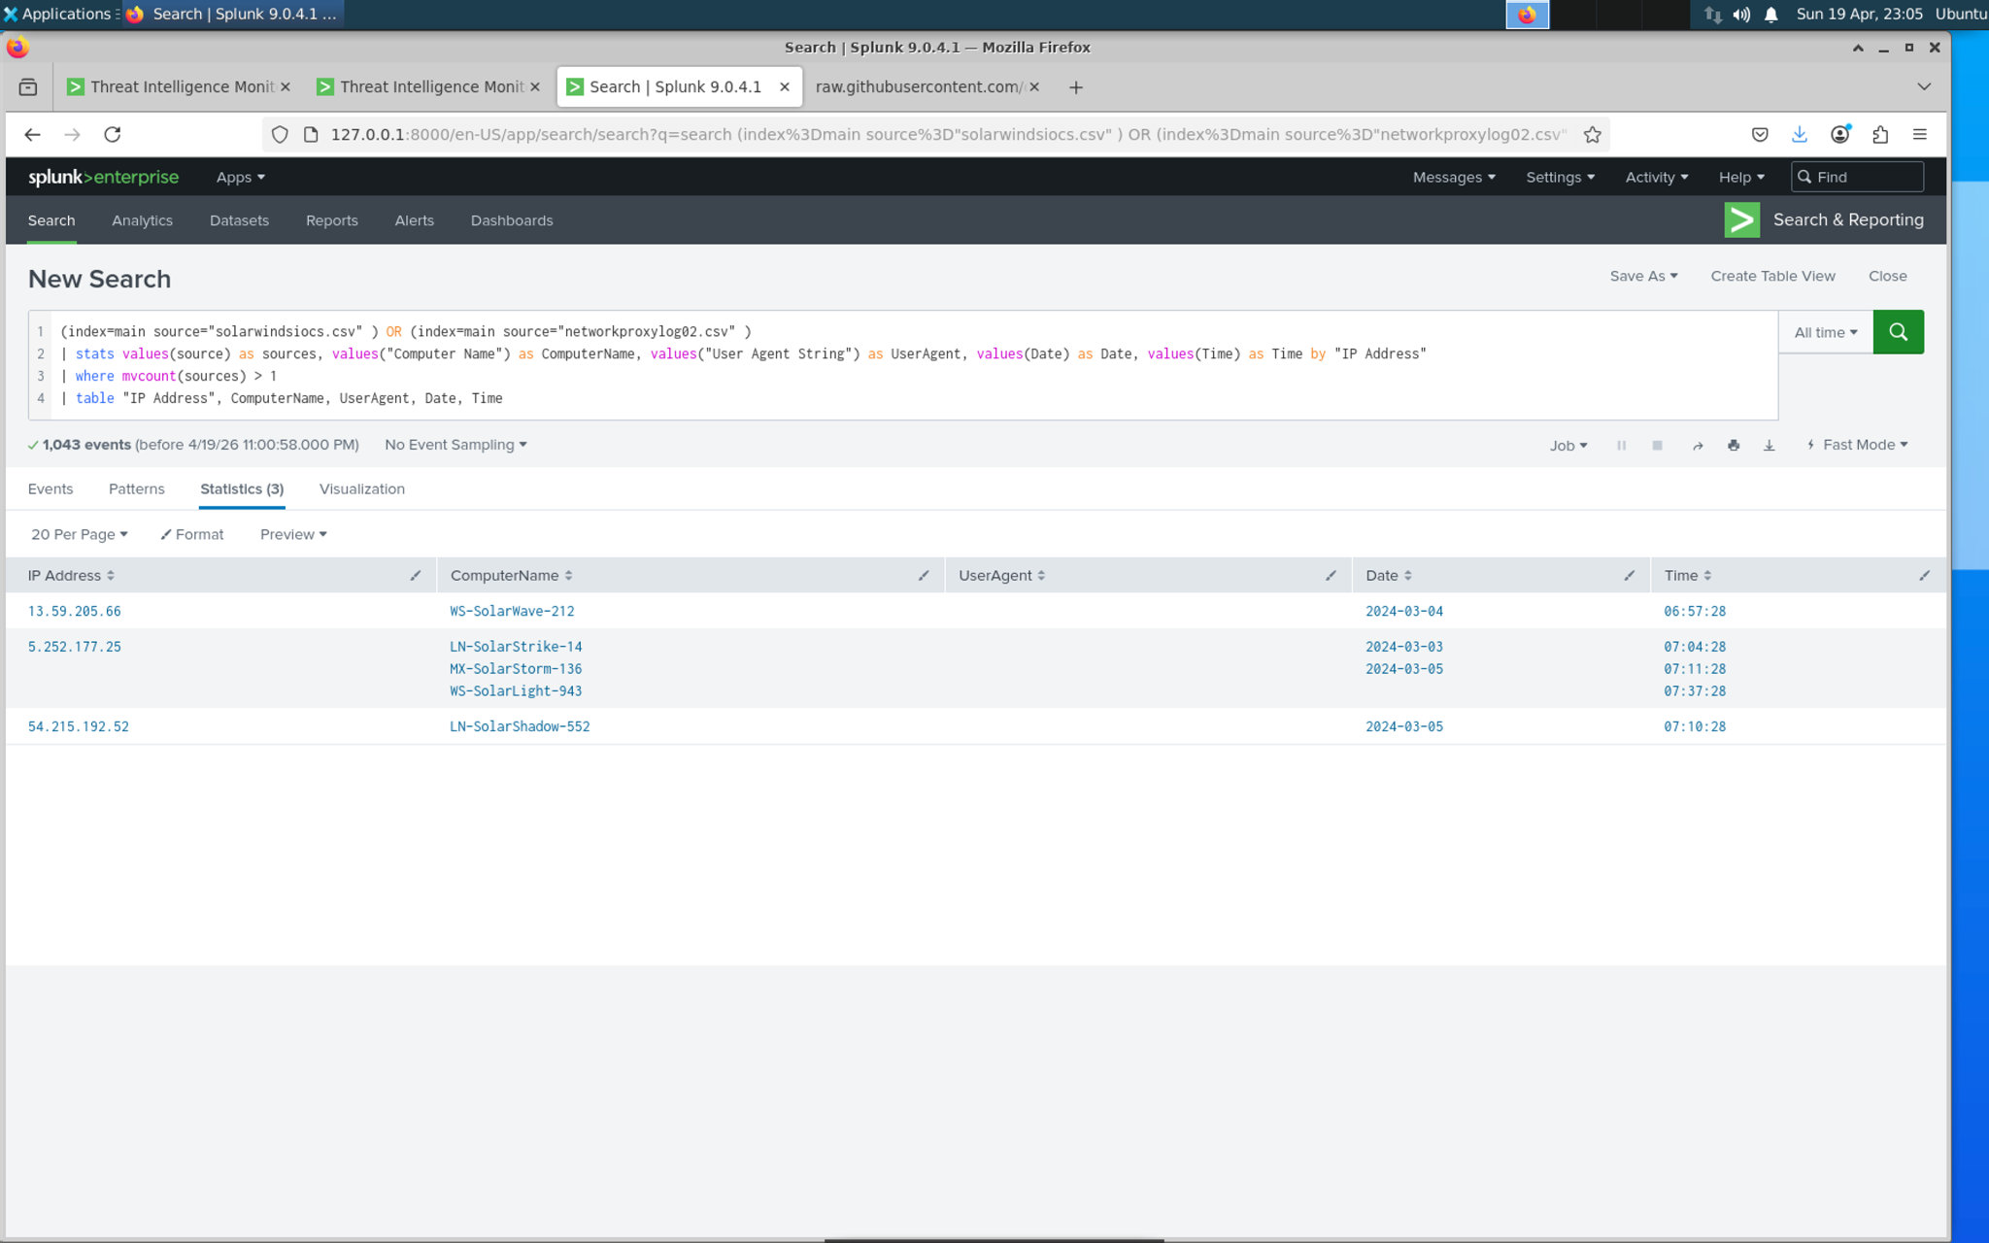
Step 3: Screenshot of VirusTotal search for the IP listed above
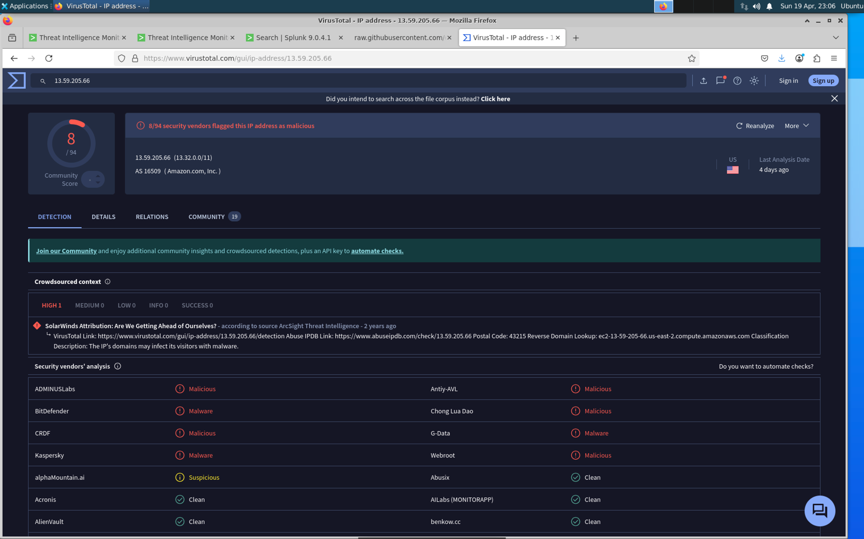

Match #2
Steps 1-2.5: General match data from Splunk (see Step 2.5)
Matched IP address: | 54.215.192.52
The event date(s) and time(s): | 2024-03-05 07:10:28
Affected computer(s): | LN-SolarShadow-552
Step 2.5: Screenshot of the match in Splunk

Step 3: Screenshot of VirusTotal search for the IP listed above
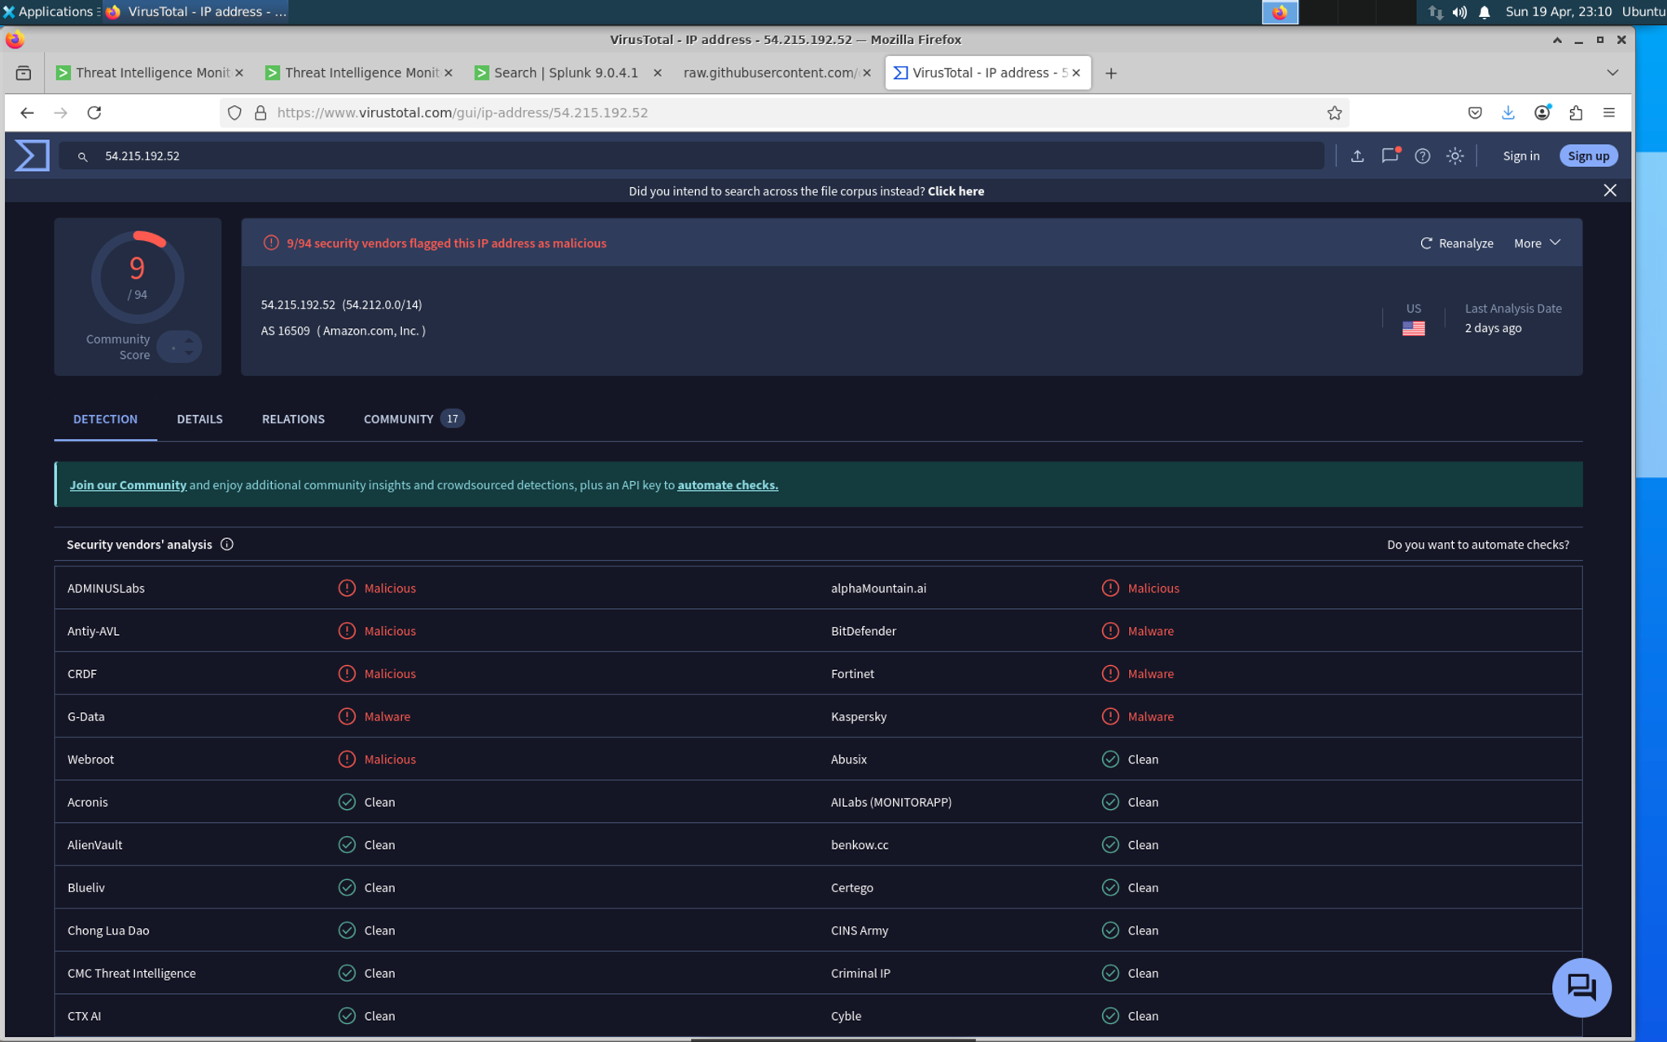
Steps 1-2.5: General match data from Splunk (see Step 2.5)

If you find a Match #3, enter it in the Stretch Challenge below!

Splunk Dashboard Query
Step 4: Enter the search query used to generate your Splunk Dashboard below
(index=main source="solarwindsiocs.csv" ) OR (index=main source="networkproxylog02.csv" )
| stats values(source) as sources, values("Computer Name") as ComputerName, values("User Agent String") as UserAgent, values(Date) as Date, values(Time) as Time by "IP Address"
| where mvcount(sources) > 1
| table "IP Address", ComputerName, UserAgent, Date, Time

Stretch Challenge (Optional)

Match #3
Steps 1-2.5: General match data from Splunk (see Step 2.5)
Matched IP address: | TODO
The event date(s) and time(s): | TODO
Affected computer(s): | TODO
Step 2.5: Screenshot of the match in Splunk
[Insert Screenshot Here]
Step 3: Screenshot of VirusTotal search for the IP listed above
[Insert Screenshot(s) Here]
Steps 1-2.5: General match data from Splunk (see Step 2.5)

Bonus Task #1
Import a new set of IOC data into Splunk, then search your network data for matches.
A link to the threat source used:
TODO
Screenshot(s) of your Splunk search that shows you investigating with the newly imported data:
[Insert Screenshot(s) Here]
A short answer describing your findings: (Even if you didn’t find anything, you should explain where you looked and why!)
TODO

Submission Checklist
👉Check off each of the features you have completed. You will only be graded on the features you check off.

Required Challenges
- Match #1
- Match #2
- Splunk Dashboard Query

Stretch Challenge
- Match #3
- Bonus Task #1

💡Tip: You can see specific grading information, including points breakdown, by going to 🔗 the grading page on the course portal.

Submit your work!
Step 1: Click the Share button at the top of your screen double check that anyone with the link can edit.

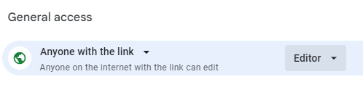

Step 2: Copy the link to this document.
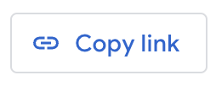

Step 3: Submit the link on the portal.

